**CARBON CAPTURE**

**USING VACUUM CLEANER**

**Team Hawking Minds**

**(Sudhansu Panigrahi (Captain), Sidhant Kumar Raut, Jyotsana Kumari Gupta)**

**Problem Statement:**

* There has been a rising concern of the increase in global temperatures and hence forth global climate change. This is due to the rising content of greenhouse gases of which carbon dioxide is one of them.
* This issue needs urgent measures and hence goes our aim to deploy some carbon capture technology to tackle. Along with this, we aim to design a setup which is cheap and easy to operate unlike the present carbon sequestration techniques

**CONTENTS:**

***Abstract***

1. ***Introduction***
2. ***Big Concept (Our solution)***
3. ***Apparatus and Interventions***
   1. ***Principles Involved***
   2. ***Working of our setup***
4. ***Unique Value Proposition and Contribution to society***
5. ***Market Size & Competitors***
6. ***Target Customers and commercialisation***
7. ***Business Model***
8. ***Conclusion***

***References***

***Abstract***

*In the wake of overall industrial and social development, building up of carbon dioxide in the atmosphere due to high emissions has led to the establishment of serious matter of concern. Global warming as its major result has a leading impact on the global climate change like melting of ice belts, droughts, rising sea level, severity and long period of summer days, shortening of winter period etc and this problem needs global scale innovation and policy interventions in order to reduce the disastrous impacts.*

*The major contributing factors to the global climate change and global warming are the greenhouse gases and carbon dioxide is one of them which has high content in atmosphere taking into account the expected amount.*

*As a group of young innovators, the aim of our project is to design an alternative method to the procedures developed for reducing the carbon dioxide emissions which would be a better one in terms of efficiency and economic aspects. Our setup uses a vacuum cleaner simulating design following physical adsorption using activated carbon filters and chemical absorption of carbon dioxide by using caustic potash or potassium hydroxide solution layer(* bound *by diffusor membranes) to mug up carbon dioxide from the input air and release air with a lower concentration of carbon dioxide back to atmosphere.*

**1.INTRODUCTION TO THE PROBLEM:**

Radiation active gases called the greenhouse gases (ozone, water vapour, carbon dioxide.....) in the atmosphere radiate energy in all directions ,a part of which is trapped in the Earth leading to the warming effect. The intensity of the warmth depends on the amount of greenhouse gases in the atmosphere. Greenhouse effect in earth has reached a very critical due the emission of the gases from burning of fossil fuels, and due to clearing of trees.

Global warming stresses ecosystems through **temperature** rises, **water** shortages, increased fire threats, drought, weed and pest invasions, intense storm damage and salt invasion, just to name a few.

The hazards that the greenhouse gases are leading to are depicted below.

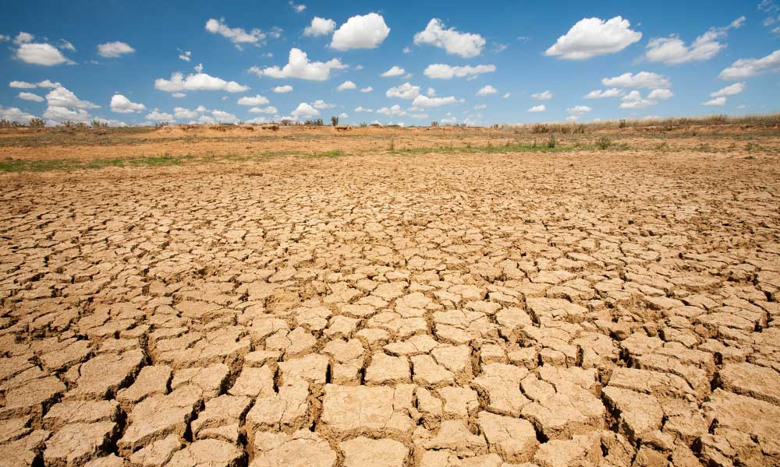

**1. Droughts**

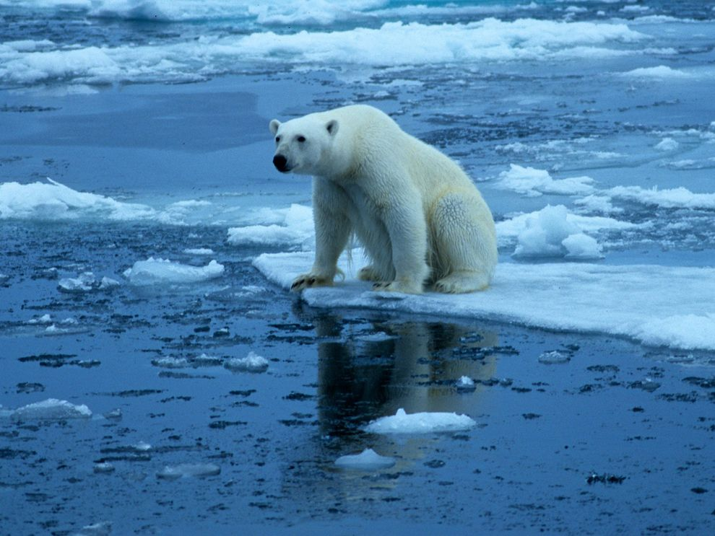

**2.Melting of Ice-Belts**

**The figure below depicts the World Meteorological organisation report what hazards global warming and greenhouse gasses has led to in terms of mankind:**

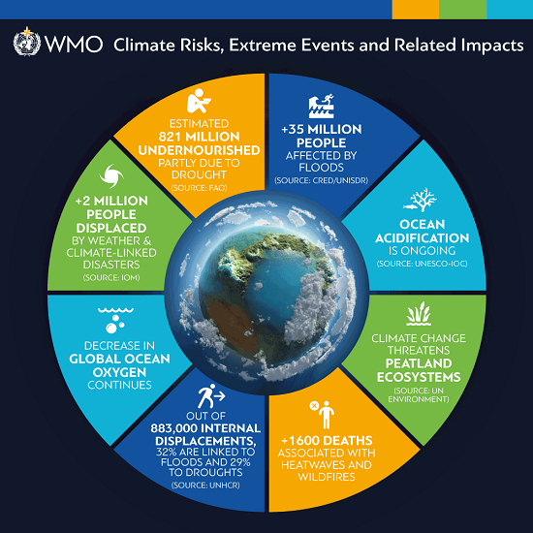

**3.WMO Report**

**2.BIG CONCEPT: -**

Our project solely aims at removal of Carbon dioxide from air by employing some carbon capture technology and provide air with a lower concentration of carbon dioxide.

Obviously, afforestation plays a key role in this regard but it has impact in long run only. The problem now needs global scale innovation so as to reduce the content of carbon dioxide from air.

Carbon capture is the only option left with us in this regard, hence goes the motive to design a cost-effective setup that can capture or suck carbon dioxide directly from air.

The basic principles governing our capture technology include physical adsorption, chemical absorption, speed control mechanism of DC motors and air flow due to pressure variations.

**3.APPARATUS AND INTERVENTIONS: -**

Our design simulates a vacuum cleaner in which three layers of activated carbon filters and one layer of potassium hydroxide (bound by diffusor membranes) are fixed to filter out carbon dioxide from the input air. The figures below show the components of our design.

The figures below show the CAD views of our design

**Outlet**

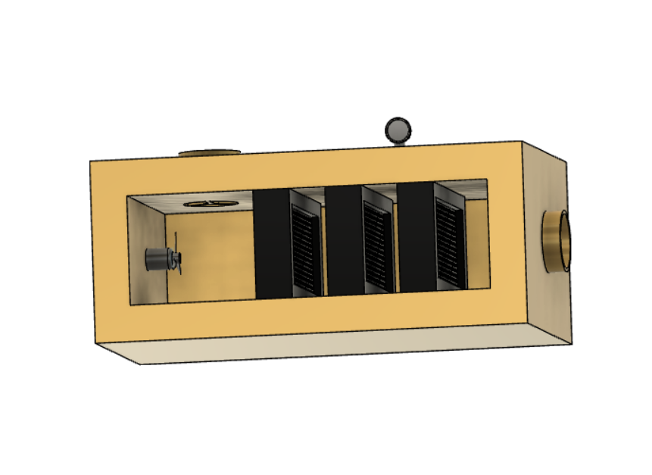

**Activated Carbon filters (3)**

**Suction fan attached to motor**

**Inlet**

**Chamber with KOH**

**Pressure Gauge**

**4. View of internal Structure**

 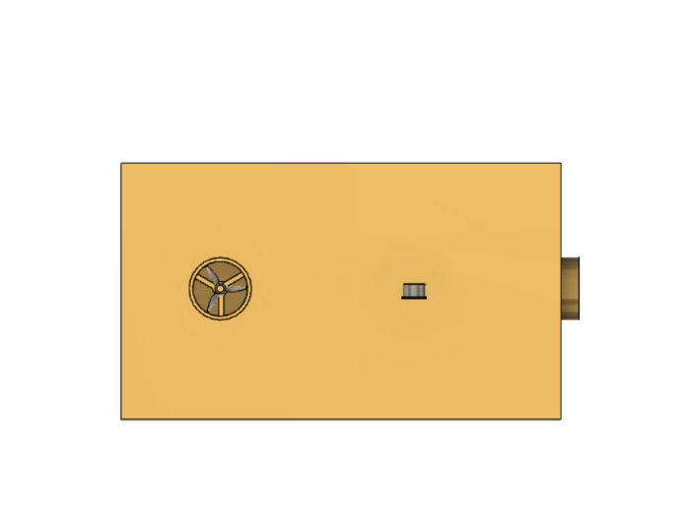

**5.Front & Top Views of our design**

**3.1. Principles Involved (in order from inlet to outlet):**

* **Air flows from a region of higher pressure to a region of low pressure:**

The pressure gauge attached to the vacuum chamber creates a pressure variation hence allowing air to rush into the chamber through the inlet.

* **Physical Adsorption using activated carbon:**

We use porous membranes impregnated with activated carbon to carry out this task. The molecules of carbon dioxide present in the input air stick to the activated carbon membranes and air with a lower concentration of carbon dioxide passes to the next stage

* **Chemical absorption by Potassium Hydroxide Membrane:**

Air when passes through a solution of potassium hydroxide bound by diffusor membranes (to maintain consistency) ,carbon dioxide reacts with it to form potassium carbonate.

**2KOH + CO2 🡪 K2CO3 + H2O**

* **Speed control of DC motor:**

To allow air to flow inside the chamber smoothly, the speed of the suction fan needs to be reduced. Using the armature resistance control technique we have installed a armature resistance variac to control the speed

The motive is to allow carbon dioxide in air to get some time to get adsorbed onto the capture technology.

**3.2. Working of our setup:**

* The pressure variation created using the pressure gauge allows air to come into the chamber via the inlet.
* Air then passes over two layers of activated carbon filters set a distance apart to allow air to get some time to adsorb onto the filters
* In the next stage, after crossing two layers of activated carbon, it passes through a chamber containing potassium hydroxide solution (bound by diffusor membranes).
* The carbon dioxide molecules react with KOH and air with a lower concentration of carbon dioxide again passes through a layer of activated carbon at the final stage.
* Finally, air with a lower concentration of carbon dioxide moves out of the vacuum cleaner simulating setup via the outlet
* The motor is fixed inside the chamber at the end onto which a centrifugal fan is attached to create suction and allow smooth air movement inside the chamber.

**4.UNIQUE VALUE PROPOSITION & CONTRIBUTION TO SOCIETY:**

* Our design is a very **cost-effective** and **easy to handle** setup that will filter out carbon dioxide **directly from air** using the capture technology discussed earlier
* Initial implementation will involve the **use of a vacuum cleaner** in which we will modify the components like the motor etc by installing armature resistance control variacs.
* It is **energy efficient** as **saves money as well as the environment** in the long run, the perfect combination
* Maintenance is subject to how the product is used on a daily basis and also the particular place. on an average, the product will require maintenance every 5-6 months of long-term usage, which we are planning to introduce as a package for a period of 5 years so as to minimise the effective maintenance cost each year.
* The captured carbon dioxide can be extracted and set to use in greenhouse environments.
* It will add to the country’s carbon credit
* It will surely contribute to the reduction in carbon dioxide concentration from the atmosphere at a much faster rate as compared to the rate at which afforestation would do it.

**5.MARKET SIZE & COMPETITORS:**

* People use maximum precautions when it comes to what kind of air they breathe in.

And this is where our innovation comes into play.

* **Carbon markets** aim to reduce greenhouse gas (GHG, or “**carbon**”) emissions cost-effectively by setting limits on emissions and enabling the **trading** of emission units, which are instruments representing emission reductions.
* The **global carbon** footprints **market size** is expected to grow from USD 9.0 billion in 2020 to USD 12.2 billion by 2025, at a Compound Annual Growth Rate (CAGR) of 6.2% during the forecast period.
* It is expected that **India** will gain at least $5 billion to $10 billion from **carbon trading** (Rs 22,500 crore to Rs 45,000 crore) over a period of time. Also, **India** is one of the largest beneficiaries of the total world **carbon** trade through the Clean Development Mechanism claiming about 31 per cent (CDM).

Carbon Market is a competitive market with the presence of various global and regional players in the market.

* There are 226 emerging companies developing innovative carbon capture, storage, and utilization solutions.

### Among them, the most successful start-ups include ‘See O2 Energy-carbon emissions to fuel’ , ‘Mirreco – Carbon Emissions Into Industrial Hemp’, Deep Branch Biotech – Carbon Recycling’, ‘Hexas Biomass – Bioenergy Carbon Capture & Sequestration’ & ‘Carbonfree Chemicals – Carbon Emissions Into Minerals’

**6.TARGET CUSTOMERS:**

### Rourkela, the steel city of Odisha has experienced high temperatures along with many other cities. For prior testing of our setup we will be approaching the Regional office of State Pollution Control Board of Odisha for testing it in the Industrial Township of Rourkela which is one of the largest dwelling societies in the city.

### Our main target customers will include local NGOs working on carbon sequestration and thermal power generation plants. We have also planned to approach the government bodies for the implementation of large-field setups.

### 7.BUSINESS MODEL:

### Below figure shows the business model for the setup:

### 

### 8.CONCLUSION: -

### *The setup is expected to filter out maximum amount of carbon dioxide to the extent possible from the input air and release air with a lower concentration of carbon dioxide back to atmosphere.*

### *Finally, we could conclude that our product “CARBON CAPTURE USING VACUUM CLEANER” will contribute to the reduction in carbon dioxide content from the atmosphere.*

### *REFERENCES: -*

### *[1] .* [*https://blogs.ei.columbia.edu/2018/11/27/carbon-dioxide-removalclimate-change/*](https://blogs.ei.columbia.edu/2018/11/27/carbon-dioxide-removalclimate-change/)

### *[2] Karl D. Hammond, Wm. Curtis ConnerJr., in Advances in Catalysis, 2013*

### *[3] Climate strategy with CO2.*

### *[4] .Report of National Science sponsored workshop July 9-10,2008*